**PIMPRI CHINCHWAD EDUCATION TRUST’S**

**PIMPRI CHINCHWAD COLLEGE OF ENGINEERING**

**SECTOR NO. 26, PRADHIKARAN, NIGDI, PUNE- 411044.**

|  |  |
| --- | --- |
|  |  |

**eGramPanchayat**

**Project ID:-** GD15

**TEAM MEMBERS**

|  |  |  |
| --- | --- | --- |
| **Sr. No** | **Name** | **Roll No.** |
| **1** | Madankar Govind Arun | TECOC332. |
| **2** | Lokhande Mehul Balaso | TECOC331 |
| **3** | Dabhade Vijay Sanjay | TECOC308 |
| **4** | Naikade Rohit Anand | TECOC339 |

**Domain Name:** Smart Systems.

**Abstract:**

**E**-Gram Panchayat is aimed at providing government services and secured information to rural citizens. It is an online secure web portal that can be accessed throughout the internet. This System may be used for executing and digitalizing the Gram panchayat activities. The Information about Schemes published by government or any other activities and billing record will be available for users. Documents like Residence Certificate, Land Records, Birth Certificates, Tax Receipts etc. can be issued to the users. Important notifications, notices, village statistical data, Contact details of the important offices and the gram panchayat’s committee members will be available on portal, which will ensure easy communication between the government and the public. This system will help to maintain and facilitate easy access to information. With two types of login, namely Admin and user, the security of the portal is maintained. The admin has the authority to maintain and change the data on the portal, approve certificates and user requests through the admin dashboard, thus enabling secure administration. With user friendly interface, the users can enjoy the services of gram panchayat at their ease.

**Methodology/Planning of work :**

**Features of our system to overcome those problems:**

1. Online and secure payment gateway to pay revenue taxes online.
2. Provide receipt of payment in pdf format.
3. Floating a govt. schemes on website to provide awareness among villagers.
4. Admin dashboard to maintain transaction data of revenue taxes and decide revenue taxes.
5. Villagers can apply for residential certificate online.
6. Villagers will get certificate through email after complete process.

**Stakeholders:**

1. Villagers as end users.
2. Gram-Panchayat officers.
3. Government officials as organizations.

**Actors:**

1. Villagers as end users.
2. Applicants for Residential Certificate.
3. Developers as Team members.

**Functional requirements:**

* **Database:**
* To store user. credentials(username,password).
* To store Applicant details.
* To store feedbacks.
* **Login/Register Page.**
* To make new account for new users.
* To give access to users with valid credentials.
* **GUI:**
* Dashboard.
* Stastical Charts.
* Google maps widget.
* **Network:**
* Server for managing dynamic data.
* Client-server architecture.
* **Server:**
* To render user requests.
* API Routing.

**Non-functional requirements**

* **Security**:
* Login credentials to enter into portal.
* Provide easy login with oAuth parties like google and facebook.
* **Reliability**:
* Validations in case of form credentials entered.
* Must handle load during high traffic.
* Can run on any device resolution.
* **Maintainability**:
* Admin Dashboard.
* Feedback System.

**Software Development Life Cycle:**

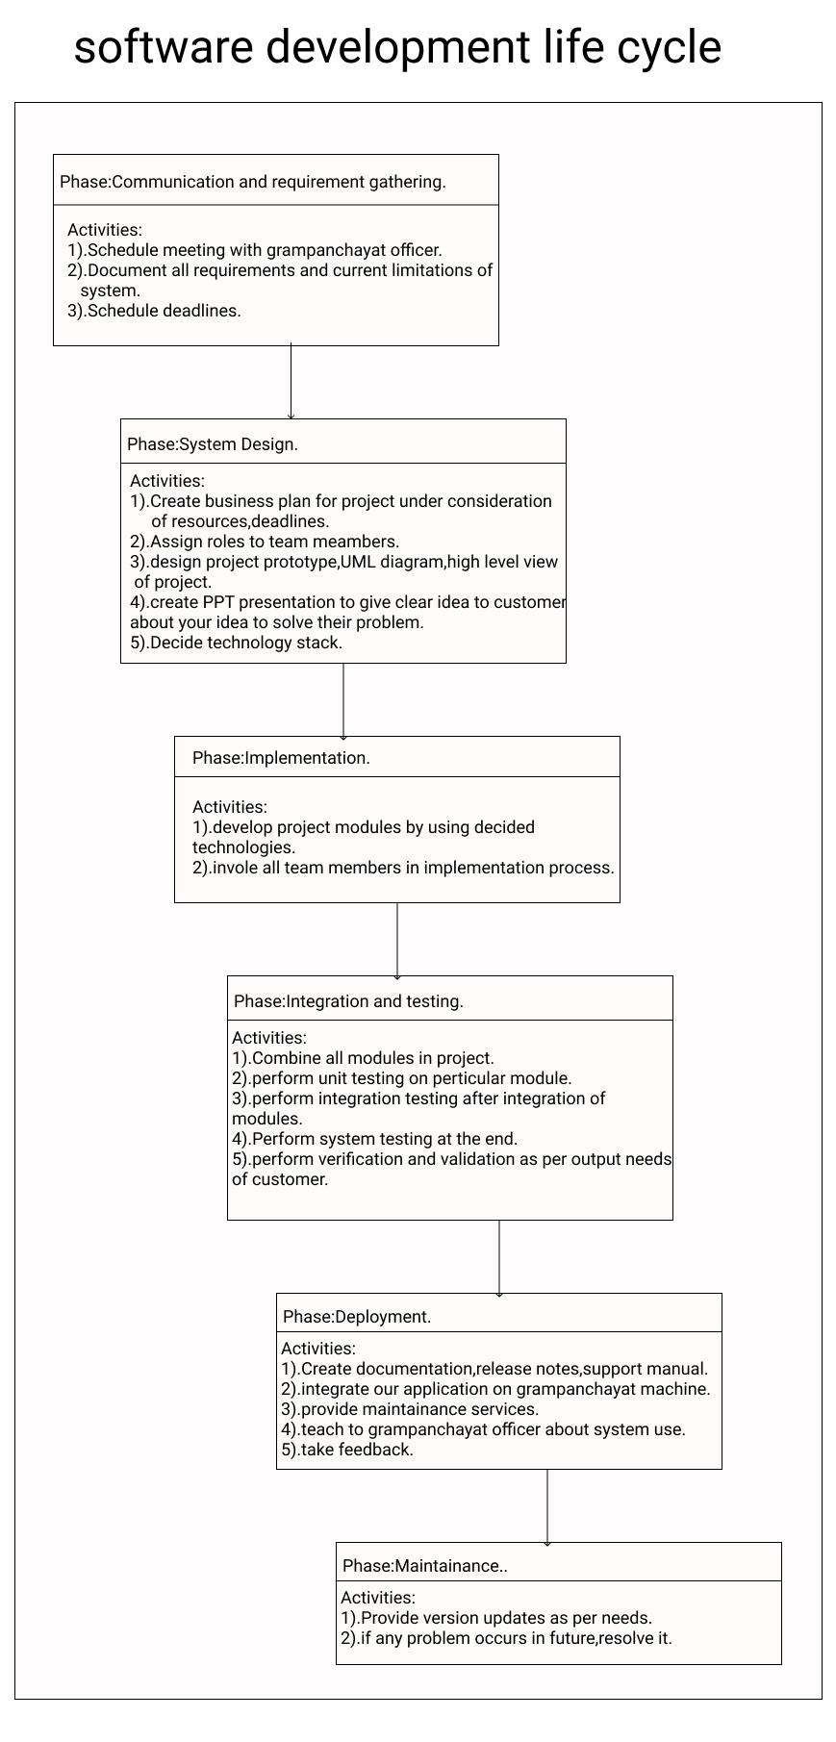

**UML use case Diagram of eGram –Panchayat:**

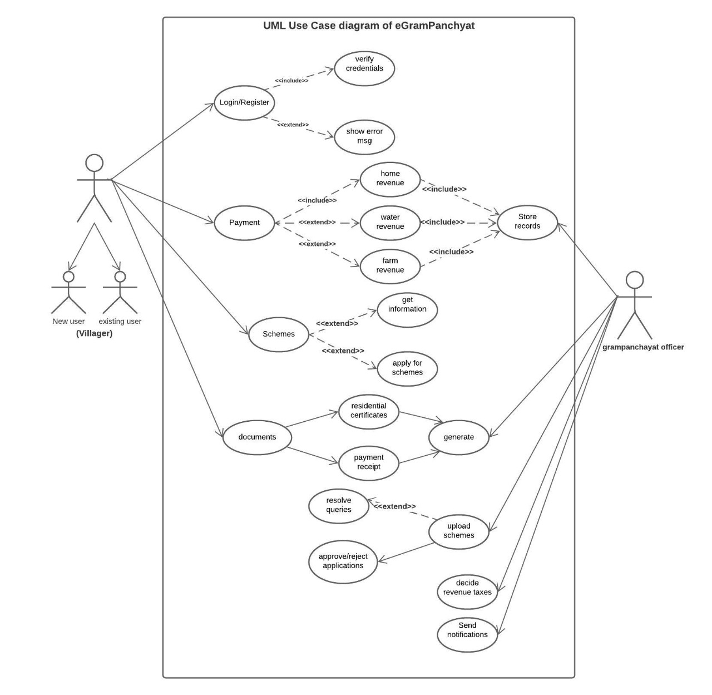

**UML Class diagram:**

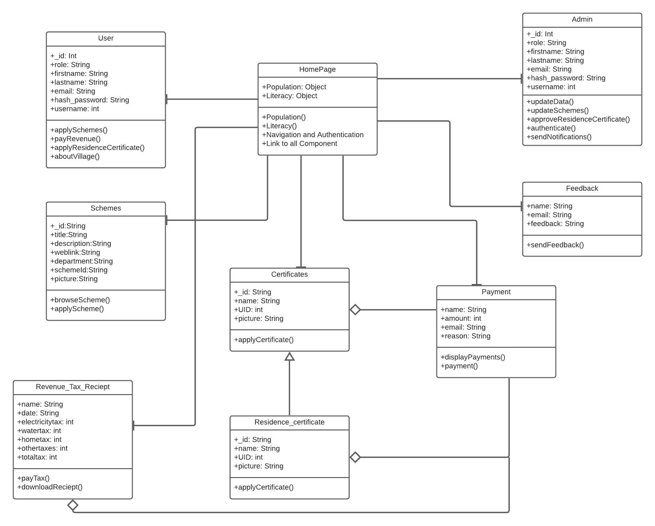

**Keywords:** E-Governance, Digital India, Self Reliant India, E-Government, Web Portal, User Friendly, Secured, Centralized Approach, Rural E-government projects, developing countries.

**References/Bibliography (Min 5):**

|  |  |
| --- | --- |
| * **Government portal Aatmanirbhar Bharat**: https://aatmanirbharbharat.mygov.in/ * **PMO portal** <https://www.pmindia.gov.in/en/>. * **Panchayati Raj System.** * **E-Gram Panchayat :** <https://www.ijresm.com/Vol.3_2020/Vol3_Iss4_April20/IJRESM_V3_I4_85.pdf> * **E-Gram Panchayat Management System :** <https://www.ijresm.com/Vol.3_2020/Vol3_Iss5_May20/IJRESM_V3_I5_24.pdf> * **Building an alternative e-governance model : lessons from e-Gram in Gujarat :** <https://idlbnc-idrc.dspacedirect.org/handle/10625/41775> * **E-GRAM PANCHAYAT MANAGEMENT SYSTEM :** <http://oaijse.com/> * **Hurdles in rural e-government projects in India: lessons for developing countries :** <http://citeseerx.ist.psu.edu> |  |
|  |  |